BABU BANARASI DAS
UNIVERSITY

2026-2027

SCHOOL OF COMPUTER APPLICATIONS
No SQL ON Project
Student Management System Using MongoDB

Submitted by: Submitted to:
Name:-Anchal Pushpakar Mr. Harendra Singh
Class:- BCA DS/AI (22)
Roll no.:-1250258085

1. CREATE DATABASE
MongoDB Query:
use Pushpakar
Explanation:Creates or switches to the Student database.

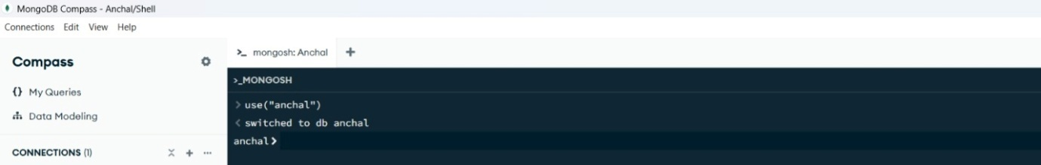
2. CREATE COLLECTION
MongoDB Query:
db.createCollection("pushpakar")
Explanation: Creates a collection named students

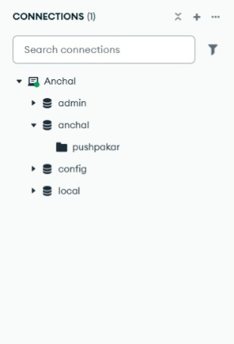
3. INSERT 50 STUDENTS
MongoDB Query:
db. pushpakar. Insert Many([ ])
{roll:1, name:"Anchal", age:19,marks:98,city:"Lucknow"},
{roll:2, name:"Rahul", age:18,marks:76,city:"Jaunpur"},
{roll:3, name:"Pooja", age:19,marks:92,city:"Kanpur"},
{roll:4, name:"Neha", age:18,marks:69,city:"Ayodhya"},
{roll:5, name:"Aman", age:19,marks:81,city:"Varanasi"},
{roll:6, name:"Priya", age:20,marks:85,city:"Lucknow"},
{roll:7, name:"Rohit", age:19,marks:73,city:"Prayagraj"},
{roll:8, name:"Sneha", age:19,marks:90,city:"Lucknow"},
{roll:9, name:"Kajal", age:20,marks:78,city:"Gorakhpur"},
{roll:10, name:"Vikas", age:18,marks:65,city:"Kanpur"},
{roll:11, name:"Mohit", age:20,marks:71,city:"Jaunpur"},
{roll:12, name:"Simran", age:19,marks:95,city:"Lucknow"},
{roll:13, name:"Nisha", age:18,marks:84,city:"Ayodhya"},
{roll:14, name:"Komal", age:19,marks:87,city:"Prayagraj"},
{roll:15, name:"Karan", age:20,marks:74,city:"Varanasi"},
{roll:16, name:"Payal", age:18,marks:89,city:"Lucknow"},
{roll:17, name:"Muskan", age:19,marks:82,city:"Kanpur"},
{roll:18, name:"Ravi", age:18,marks:58,city:"Gonda"},
{roll:19, name:"Shivani", age:20,marks:91,city:"Lucknow"},
{roll:20, name:"Arjun", age:19,marks:63,city:"Bareilly"},
{roll:21, name:"Deepak", age:18,marks:77,city:"Lucknow"},
{roll:22, name:"Sakshi", age:19,marks:86,city:"Jaunpur"},
{roll:23, name:"Kavita", age:20,marks:72,city:"Kanpur"},
{roll:24, name:"Rakesh", age:19,marks:80,city:"Ayodhya"},
{roll:25, name:"Manish", age:18,marks:67,city:"Prayagraj"},
{roll:26, name:"Aarti", age:20,marks:94,city:"Lucknow"},
{roll:27, name:"Divya", age:19,marks:88,city:"Varanasi"},
{roll:28, name:"Saurabh", age:18,marks:61,city:"Gorakhpur"},
{roll:29, name:"Nikhil", age:19,marks:75,city:"Kanpur"},
{roll:30, name:"Varun", age:20,marks:79,city:"Lucknow"},
{roll:31, name:"Sumit", age:18,marks:68,city:"Jaunpur"},
{roll:32, name:"Tanya", age:19,marks:90,city:"Lucknow"},
{roll:33, name:"Akash", age:20,marks:55,city:"Ayodhya"},
{roll:34, name:"Yash", age:18,marks:83,city:"Kanpur"},
{roll:35, name:"Shubham", age:19,marks:96,city:"Prayagraj"},
{roll:36, name:"Ritu", age:20,marks:70,city:"Lucknow"},
{roll:37, name:"Harsh", age:18,marks:81,city:"Varanasi"},
{roll:38, name:"Abhishek", age:19,marks:66,city:"Gorakhpur"},
{roll:39, name:"Dev", age:20,marks:93,city:"Lucknow"},
{roll:40, name:"Preeti", age:19,marks:85,city:"Kanpur"},
{roll:41, name:"Jyoti", age:18,marks:74,city:"Jaunpur"},
{roll:42, name:"Anjali", age:20,marks:89,city:"Lucknow"},
{roll:43, name:"Shweta", age:19,marks:62,city:"Ayodhya"},
{roll:44, name:"Pankaj", age:18,marks:78,city:"Prayagraj"},
{roll:45, name:"Isha", age:20,marks:84,city:"Lucknow"},
{roll:46, name:"Mansi", age:19,marks:73,city:"Kanpur"},
{roll:47, name:"Vivek", age:18,marks:59,city:"Gonda"},
{roll:48, name:"Rashmi", age:20,marks:87,city:"Lucknow"},
{roll:49, name:"Amit", age:19,marks:64,city:"Bareilly"},
{roll:50, name:"Shreya", age:18,marks:91,city:"Varanasi"}
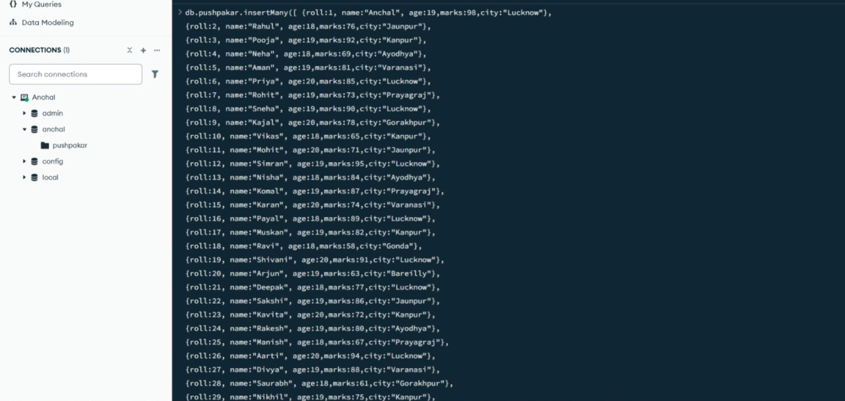 Explanation: Inserts multiple student documents into the collection

4. DISPLAY ALL STUDENTS
MongoDB Query:
db.pushpakar.Find()
Explanation:Retrieves documents from the students collection.

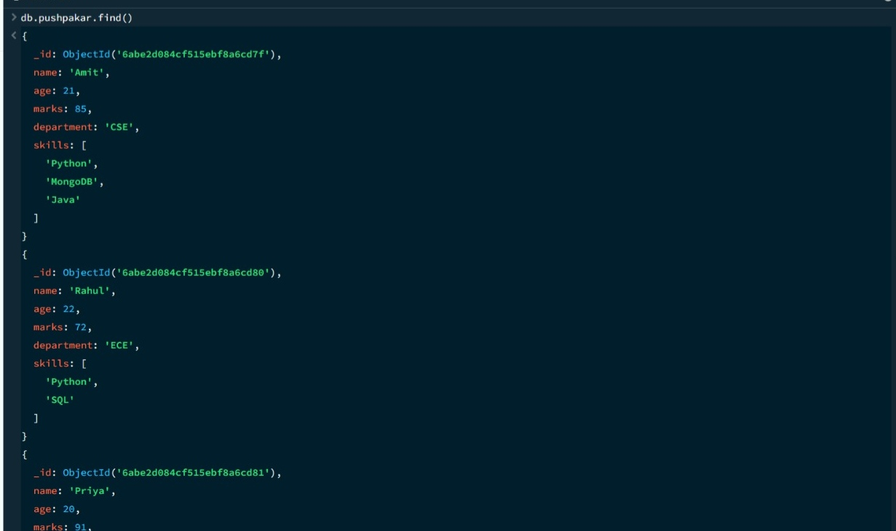

5. EQUAL TO — $eq
MongoDB Query:
db.pushpakar.Find({marks: {$eq: 88}})
Explanation: Finds students whose marks are exactly 88.
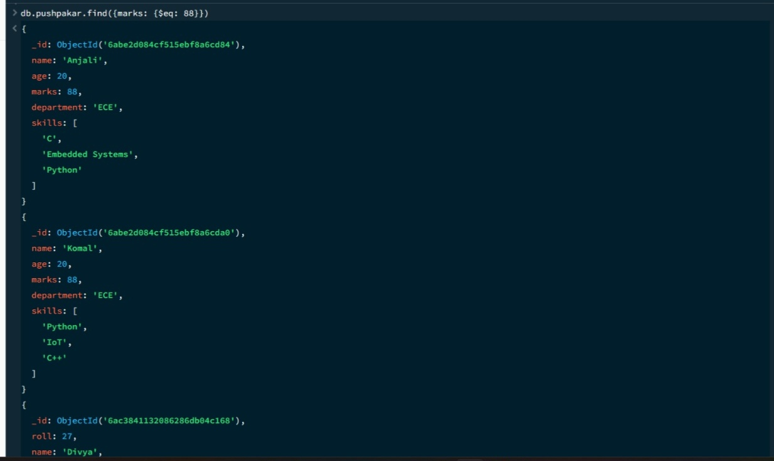
6. GREATER THAN — $gt
MongoDB Query:
db.pushpakar.find({marks: {$gt: 85}})
Explanation:Finds students whose marks are greater than 85.
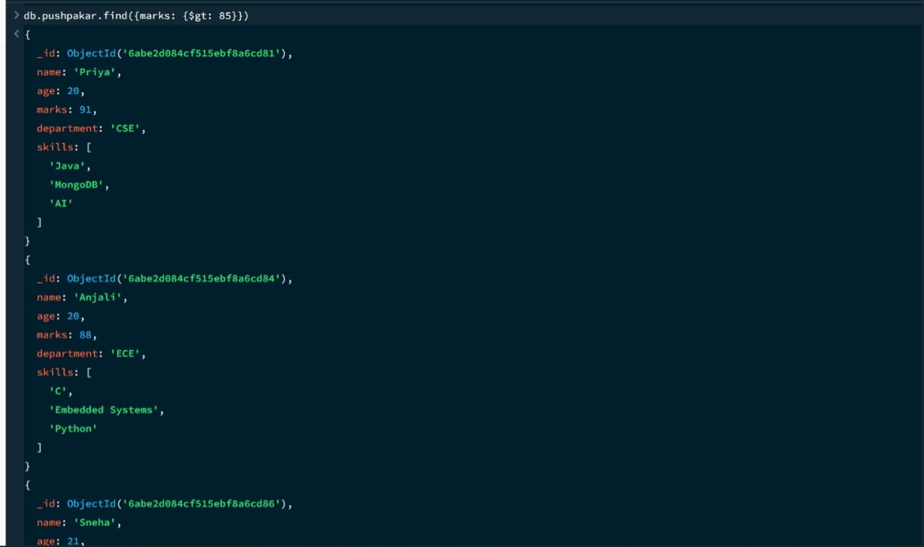
7. LESS THAN — $lt
MongoDB Query:
db.pushpakar.find({marks: {$lt: 60}})
Explanation:Finds students whose marks are less than 60.

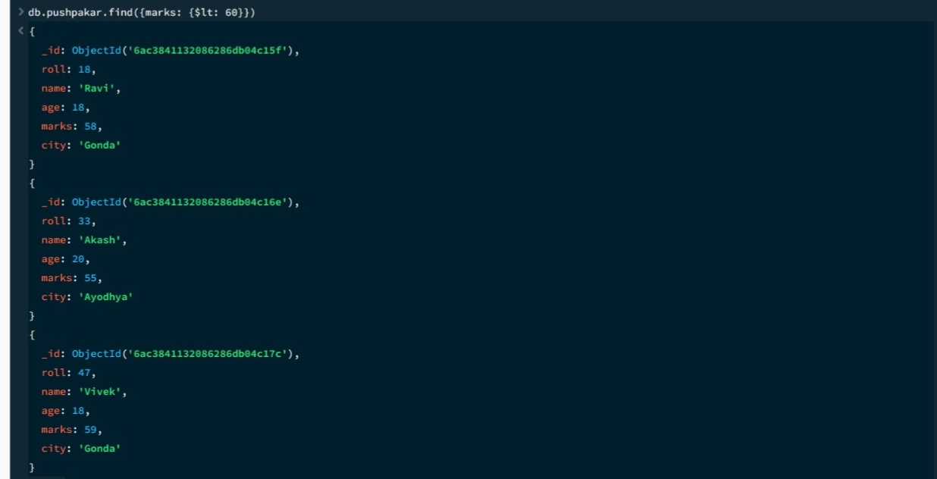

8. GREATER THAN OR EQUAL TO — $gte
MongoDB Query:
db.pushpakar.find({marks: {$gte: 90}})
Explanation:Finds students whose marks are 90 or above.
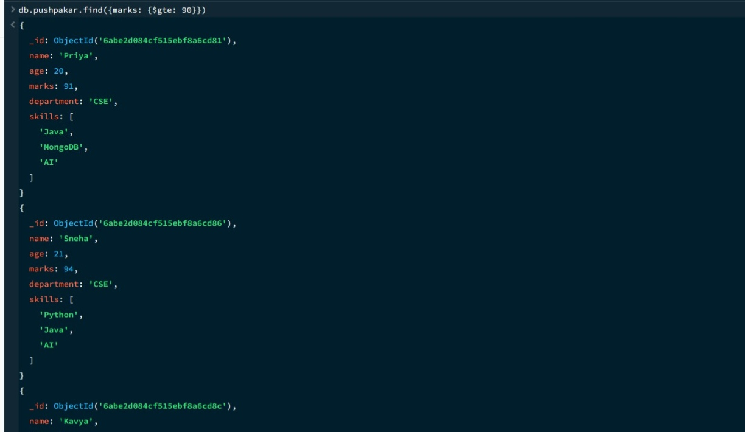

9. LESS THAN OR EQUAL TO — $lte
MongoDB Query:
db.pushpakar.find({marks: {$lte: 70}})
Explanation:Finds students whose marks are 70 or below.
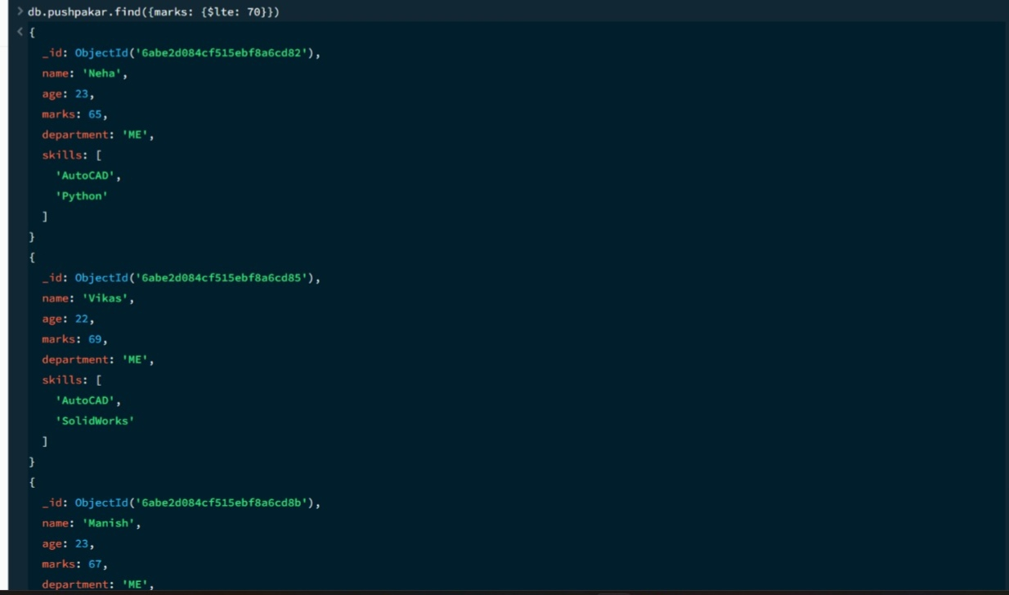
10. UPDATE OPERATION
MongoDB Query:
db.pushpakar.updateOne(
{roll:5},
{$set:{marks:95}}
)
Explanation:Updates the marks to 95 of the student with roll number 5.
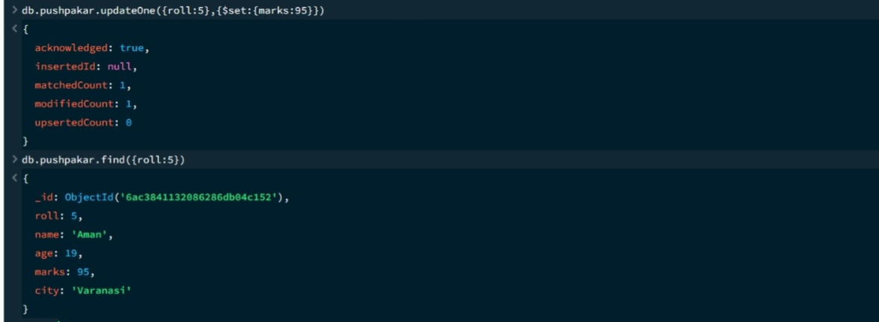

11. DELETE ONE OPERATION
MongoDB Query:
db.pushpakar.deleteOne({roll:10})
Explanation: Deletes one document matching roll number 10.
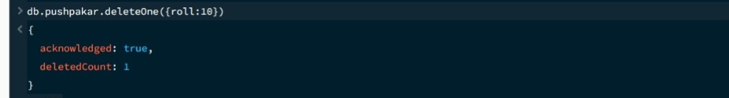

12. DELETE MANY OPERATION
MongoDB Query:
db.pushpakar.deleteMany({
marks: {$lt:60}
})
Explanation: Deletes all students having marks below 60.
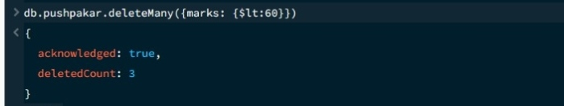

13. AND OPERATION — $and
MongoDB Query:
db.pushpakar.find({
$and:[
{marks:{$gt:80}},
{age:19}
]
})
Explanation: Finds students satisfying both conditions.
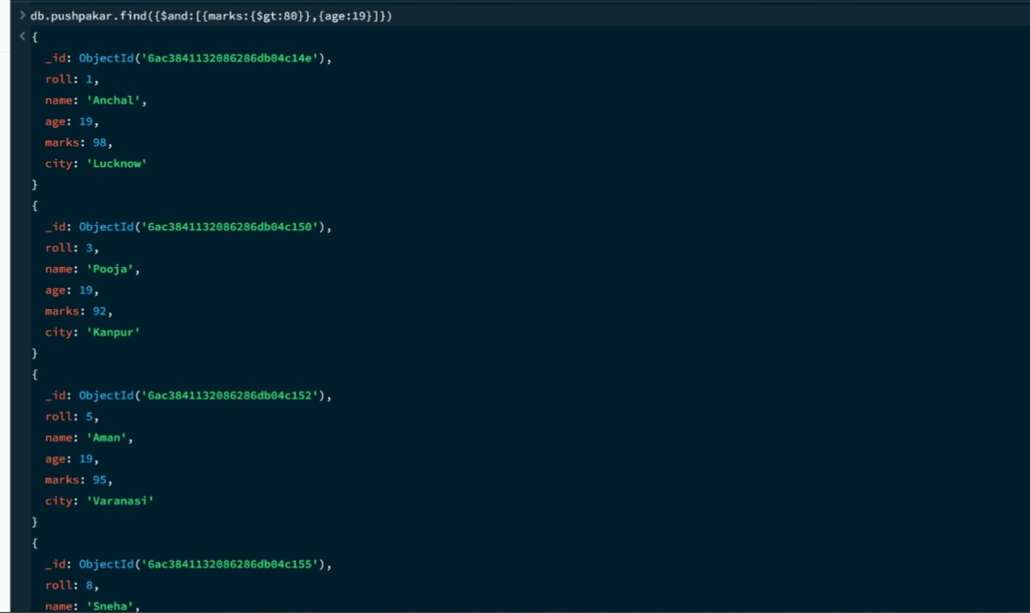

14. OR OPERATION — $or
MongoDB Query:
db.pushpakar.find({
$or:[
{city:"Lucknow"},
{city:"Kanpur"}
]
})
Explanation:Finds students from Lucknow or Kanpur.
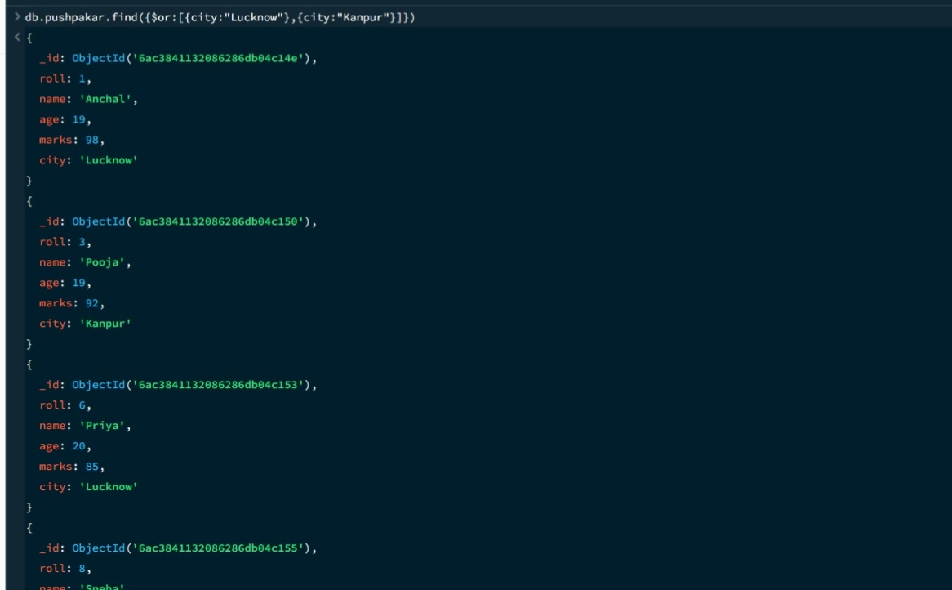

15. SORT OPERATION
A.MongoDB Query:
db.pushpakar. find().sort({marks :1})
Explanation:Sorts students by marks from lowest to highest. Use 1 for ascending order.
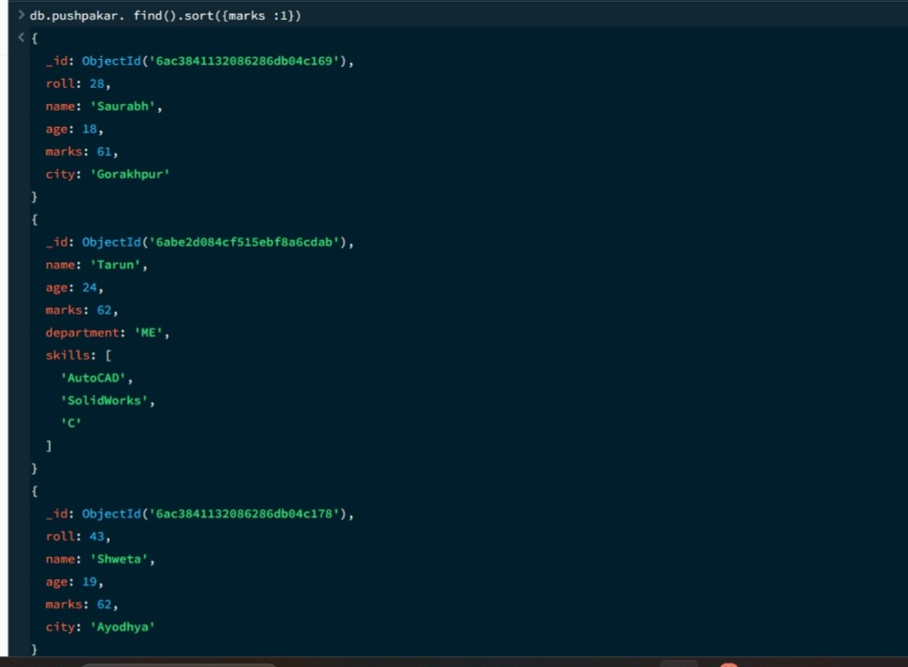

B. MongoDB Query:
db pushpakar. find(). Sort({marks: -1})
Explanation:Sorts students by marks from highest to lowest. Use -1 for descending order.
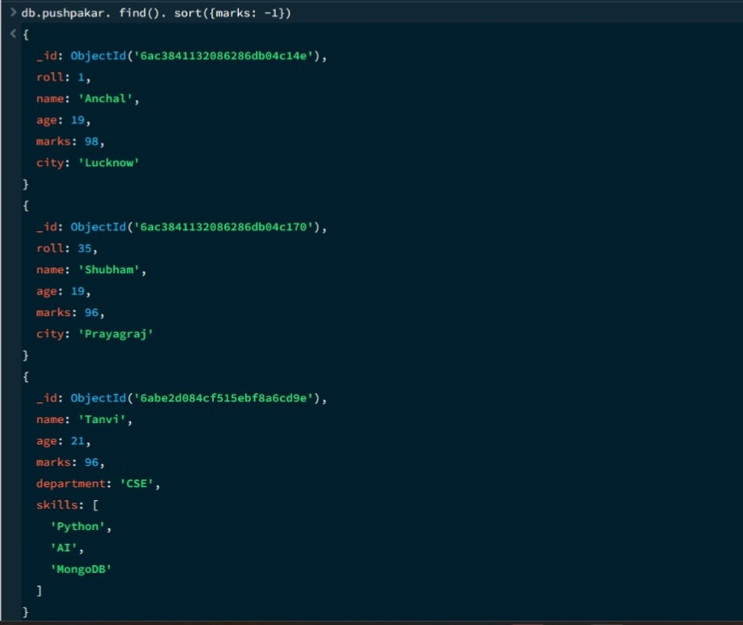

16. LIMIT OPERATION
MongoDB Query:
db.pushpakar.find(). limit(5)
Explanation: Displays only the first five documents.
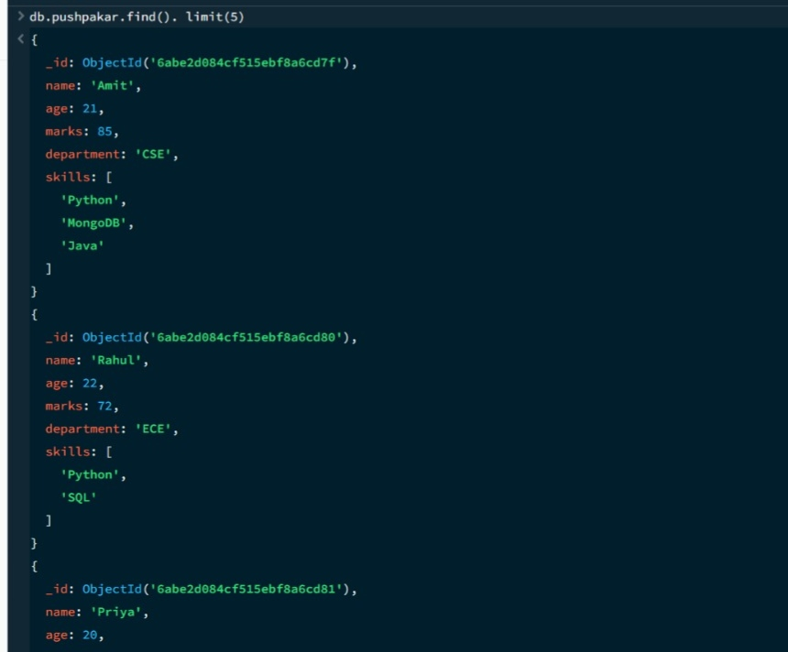

17. SEARCH BY CITY
MongoDB Query:
db .pushpakar.find({city:"Lucknow"})
Explanation:Finds all students whose city is Lucknow.
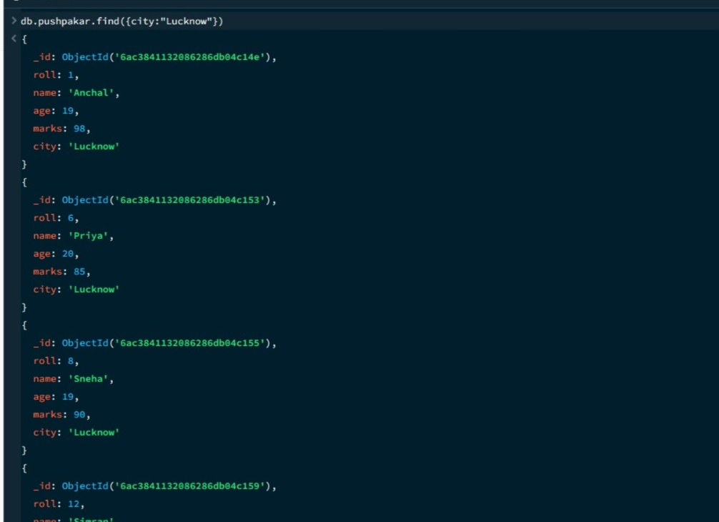

18. COUNT DOCUMENTS
MongoDB Query:
db. pushpakar.countDocuments()
Explanation:Counts documents currently present in the collection (performing after the delete function).
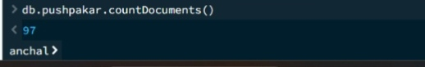

MONGODB OPERATORS USED:

Operator | Meaning | Example
$eq | Equal to | marks: {$eq:88}
$gt | Greater than | marks: {$gt:85}
$lt | Less than | marks: {$lt:60}
$gte | Greater than or equal to | marks: {$gte:90}
$lte | Less than or equal to | marks: {$lte:70}
$and | All conditions true | $and:[...]
$or | At least one condition true | $or:[...]

CONCLUSION
This project provided practical knowledge of NoSQL databases using MongoDB. A Student Management System containing student information was created and different MongoDB operations were performed on the data.
Through this project, I learned how to insert, retrieve, update, and delete documents. I also learned how to Ascending order &descending order data, comparison operators such as $eq, $gt, $lt, $gte, and $lte work, along with logical operators such as $and and $or.
Overall, this project helped me understand how MongoDB can be used to manage and query student data efficiently.

